

AI19741 - BIG DATA TECHNOLOGY

Sanjay S

IV/AIML/B

2116211501087

2116211501087

VII

AI19741 Big Data Technology | 211501087

RAJALAKSHMI ENGINEERING COLLEGE

[AUTONOMOUS]

RAJALAKSHMI NAGAR, THANDALAM – 602 105

Name : | Sanjay S
Academic Year : | 2024-2025 | Semester : 07 Branch : AIML

Register No.

2116211501087

Certified that this is the bonafide record of work done by the above student in the AI19741 – BIG DATA TECHNOLOGY during the year 2024 - 2025.

Signature of Faculty in-charge

Submitted for the Practical Examination held on 21-11-2024

Internal Examiner External Examiner

AI19741 Big Data Technology | 211501087

INDEX

S.NO | DATE | NAME OF EXPERIMENT | PG.NO | MARKS | SIGN
1 | 9/8/2024 | Installation of Hadoop Framework | 1
2 | 23/8/2024 | File Management tasks in Hadoop | 3
3 | 30/8/2024 | Implement word count program using Map | 5
 |  | Reduce
4 | 6/9/2024 | Map Reduce Program for Weather Report | 7
5.a | 20/9/2024 | Pig Latin scripts to sort, group | 11
5.b | 20/9/2024 | Pig Latin scripts to project, and filter your data. | 13
6.a | 4/10/2024 | Hive Databases -> Tables, Views | 14
6.b | 4/10/2024 | Hive Databases-> Functions and Indexes | 16
7 | 18/10/2024 | Export data from Hadoop using Sqoop | 18

AI19741 Big Data Technology | 211501087



9/8/2024

AIM:

Installation of Hadoop Framework, it‘s components and study the HADOOP ecosystem Hadoop is an open-source framework that allows to store and process big data in a distributed environment across clusters of computers using simple programming models. It is designed to scale up from single servers to thousands of machines, each offering local computation and storage.

Hadoop Architecture:

The Apache Hadoop framework includes following four modules:

Hadoop Common:

Contains Java libraries and utilities needed by other Hadoop modules. These libraries give file system and OS level abstraction and comprise of the essential Java files and scripts that are required to start Hadoop.

Hadoop Distributed File System (HDFS): A distributed file-system that provides highthroughput access to application data on the community machines thus providing very high

aggregate bandwidth across the cluster.

Hadoop YARN: A resource-management framework responsible for job scheduling and cluster

resource management.

Hadoop MapReduce: This is a YARN- based programming model for parallel processing of large data sets.

Hadoop Installation procedure: Step 1: Download and install Java https://www.oracle.com/java/technologies/javase-downloads.html Step 2: Download Hadoop

https://hadoop.apache.org/releases.html

Step 3: Set Environment Variables

Step 4: Setup Hadoop

ou must configure Hadoop in this phase by modifying several configuration files. Navigate to the

“etc/hadoop” folder in the Hadoop folder. You must make changes to three files:

core-site.xml

<configuration>
<property>

AI19741 Big Data Technology | 1 | 211501087

<name>fs.default.name</name>

<value>hdfs://localhost:9000</value>

</property>

</configuration>

hdfs-site.xml
<configuration>

<property>

<name>dfs.replication</name>

<value>1</value>

</property>

<property>

<name>dfs.namenode.name.dir</name>

<value>file:/hadoop-3.3.1/data/namenode</value>

</property>

<property>

<name>dfs.datanode.data.dir</name>

<value>file:/hadoop-3.3.1/data/datanode</value>

</property>

</configuration>

mapred-site.xml
<configuration>

<property>

<name>mapred.job.tracker</name>

<value>localhost:54311</value>

</property>

</configuration>

Step 5: Format Hadoop NameNode
hadoop namenode –format

Step 6: Start Hadoop
start-all.cmd

Step 7: Verify Hadoop Installation
http://localhost:50070/.

RESULT :

The program for the given problem statement is executed and output is verified successfully.

AI19741 Big Data Technology | 2 | 211501087



23/8/2024

AIM:

To perform various file operation in HDFS

Step 1: Adding Files and Directories to HDFS

Before running Hadoop programs on data stored in HDFS, the data needs to be added to HDFS.

Let's start by creating a directory and adding a file to it.

- Create a directory in HDFS: hadoop fs -mkdir /user/myfile
This command creates a new directory named myfile in the /user directory in HDFS.

- Add a file to HDFS:

hadoop fs -put a.txt

This command uploads the file a.txt from the local filesystem to the root directory of HDFS.

- Add the file to the newly created directory: hadoop fs -put a.txt /user/myfile

This command uploads the file a.txt from the local filesystem directly into the /user/myfile directory in HDFS.

Step 2: Retrieving Files from HDFS

To copy files from HDFS back to the local filesystem, use the get command. Here’s how to retrieve a.txt:

hadoop fs -cat a.txt

This command displays the contents of the file a.txt directly to the console. To actually copy the

file to the local filesystem, you would use:

hadoop fs -get a.txt /local/path

Replace /local/path with the desired path on your local filesystem.

Step 3: Deleting Files from HDFS

To delete a file from HDFS, use the rm command. Here’s how to delete a.txt:

hadoop fs -rm a.txt

This command removes the file a.txt from HDFS.

Output

The successful execution of the above commands will result in the following:

- Creation of the /user/myfile directory in HDFS.

- Addition of a.txt to HDFS and then to /user/myfile.

- Retrieval of a.txt from HDFS to the local filesystem.

- Deletion of a.txt from HDFS.

AI19741 Big Data Technology | 3 | 211501087

RESULT :

The program for the given problem statement is executed and output is verified successfully.

AI19741 Big Data Technology | 4 | 211501087



30/8/2024

AIM:

To implementing distinct word count problem using Map-Reduce

The function of the mapper is as follows:

- Create a IntWritable variable 'one' with value as 1

- Convert the input line in Text type to a String

- Use a tokenizer to split the line into words

- Iterate through each word and a form key value pairs as Assign each work from the tokenizer

(of String type) to a Text 'word'

- Form key value pairs for each word as < word,one > and push it to the output collector The function of Sort and Group:

After this, "aggregation" and "Shuffling and Sorting" done by framework. Then Reducers task these final pair to produce output.

The function of the reducer is as follows

- Initialize a variable 'sum' as 0

- Iterate through all the values with respect to a key and sum up all of them

- Push to the output collector the Key and the obtained sum as value

For Example:

For the given sample input1 data file (input1.txt : Hello World Bye World) mapper emits:

<Hello,1>

<World,1>

<Bye,1>

<World,1>

The second input2 data file (input2.txt : Hello Hadoop Goodbye Hadoop) mapper emits:

<Hello,1>

<Hadoop,1>

<Goodbye,1>

<Hadoop,1>

WordCount also specifies a combiner. Hence, the output of each map is passed through the local

combiner (which is same as the Reducer as per the job configuration) for local aggregation, after

being sorted on the keys.

The output of the first map:

<Hello,1>

<Bye,1>

<World,2>

AI19741 Big Data Technology | 5 | 211501087

The output of the second map:

<Hello,1>

<Hadoop,2>

<Goodbye,1>

The Reducer implementation via the reduce method just sums up the values, which are the occurence counts for each key (i.e. words in this example).

Thus the output of the job is:

<Goodbye,1>

<Bye,1>

<Hello,2>

<Hadoop,2>

<World,2>

RESULT :

The program for the given problem statement is executed and output is verified successfully.

AI19741 Big Data Technology | 6 | 211501087



6/9/2024

AIM:

To write a Map Reduce Program to analyze time-temperature statistics and generate report with

max/min temperature Weather Report POC.

Program:

- importing Libraries import java.io.IOException; import java.util.Iterator;
import org.apache.hadoop.fs.Path;

import org.apache.hadoop.io.LongWritable; import org.apache.hadoop.io.Text;

import org.apache.hadoop.mapreduce.lib.input.FileInputFormat; import org.apache.hadoop.mapreduce.lib.output.FileOutputFormat; import org.apache.hadoop.mapreduce.lib.output.TextOutputFormat; import org.apache.hadoop.mapreduce.lib.input.TextInputFormat; import org.apache.hadoop.mapreduce.Job;

import org.apache.hadoop.mapreduce.Mapper; import org.apache.hadoop.mapreduce.Reducer; import org.apache.hadoop.conf.Configuration; public class MyMaxMin {
- Mapper

/*MaxTemperatureMapper class is static

- and extends Mapper abstract class

- having four Hadoop generics type

- LongWritable, Text, Text, Text.

*/

public static class MaxTemperatureMapper extends Mapper<LongWritable, Text, Text, Text> {
/**

- @method map

- This method takes the input as a text data type.

- Now leaving the first five tokens, it takes

- 6th token is taken as temp_max and

- 7th token is taken as temp_min. Now

- temp_max > 30 and temp_min < 15 are

- passed to the reducer.

*/

- the data in our data set with

- this value is inconsistent data

AI19741 Big Data Technology | 7 | 211501087

public static final int MISSING = 9999;

@Override

public void map(LongWritable arg0, Text Value, Context context)

throws IOException, InterruptedException {

- Convert the single row(Record) to

- String and store it in String

- variable name line

String line = Value.toString();

- Check for the empty line if (!(line.length() == 0)) {
- from character 6 to 14 we have

- the date in our dataset

String date = line.substring(6, 14);

- similarly we have taken the maximum

- temperature from 39 to 45 characters

float temp_Max = Float.parseFloat(line.substring(39, 45).trim());

- similarly we have taken the minimum

- temperature from 47 to 53 characters

float temp_Min = Float.parseFloat(line.substring(47, 53).trim());

- if maximum temperature is

- greater than 30, it is a hot day if (temp_Max > 30.0) {

- Hot day

context.write(new Text("The Day is Hot Day :" + date), new

Text(String.valueOf(temp_Max)));

}

- if the minimum temperature is

- less than 15, it is a cold day

if (temp_Min < 15) {

// Cold day

context.write(new Text("The Day is Cold Day :" + date), new Text(String.valueOf(temp_Min))); }

}

}

}

// Reducer

/*MaxTemperatureReducer class is static

and extends Reducer abstract class

having four Hadoop generics type

Text, Text, Text, Text.

*/

public static class MaxTemperatureReducer extends Reducer<Text, Text, Text, Text> { /**

* @method reduce

AI19741 Big Data Technology ⁸ 211501087

- This method takes the input as key and

- list of values pair from the mapper,

- it does aggregation based on keys and

- produces the final context.

*/

public void reduce(Text Key, Iterator<Text> Values, Context context)

throws IOException, InterruptedException {

- putting all the values in

- temperature variable of type String

String temperature = Values.next().toString();

context.write(Key, new Text(temperature));

}

}

/**

- @method main

- This method is used for setting

- all the configuration properties.

- It acts as a driver for map-reduce

- code.

*/

public static void main(String[] args) throws Exception {

- reads the default configuration of the

- cluster from the configuration XML files Configuration conf = new Configuration();
- Initializing the job with the

- default configuration of the cluster

- Assigning the driver class name job.setJarByClass(MyMaxMin.class);

- Key type coming out of mapper job.setMapOutputKeyClass(Text.class);

- value type coming out of mapper job.setMapOutputValueClass(Text.class);

- Defining the mapper class name job.setMapperClass(MaxTemperatureMapper.class);

- Defining the reducer class name job.setReducerClass(MaxTemperatureReducer.class);
- Defining input Format class which is

- responsible to parse the dataset

- into a key value pair job.setInputFormatClass(TextInputFormat.class);
- Defining output Format class which is

- responsible to parse the dataset

- into a key value pair job.setOutputFormatClass(TextOutputFormat.class);
- setting the second argument

AI19741 Big Data Technology | 9 | 211501087

Path OutputPath = new Path(args[1]);

- Configuring the input path

- from the filesystem into the job FileInputFormat.addInputPath(job, new Path(args[0]));
- Configuring the output path from

- the filesystem into the job FileOutputFormat.setOutputPath(job, new Path(args[1]));
- deleting the context path automatically

- from hdfs so that we don't have

- to delete it explicitly

- exiting the job only if the

- flag value becomes false System.exit(job.waitForCompletion(true) ? 0 : 1);
}

}

RESULT :

The program for the given problem statement is executed and output is verified successfully.

AI19741 Big Data Technology | 10 | 211501087



20/9/2024

AIM:

To write a script for sorting and grouping of data.

Student data:

Assume we have a file student_data.txt in HDFS with the following content.
001,Rajiv,Reddy,21,9848022337,Hyderabad
002,siddarth,Battacharya,22,9848022338,Kolkata
003,Rajesh,Khanna,22,9848022339,Delhi
004,Preethi,Agarwal,21,9848022330,Pune
005,Trupthi,Mohanthy,23,9848022336,Bhuwaneshwar
006,Archana,Mishra,23,9848022335,Chennai
007,Komal,Nayak,24,9848022334,trivendram
008,Bharathi,Nambiayar,24,9848022333,Chennai

Step 1:

Load and store the student data in HDFS .

grunt> student = LOAD 'hdfs://localhost:9000/pig_data/student_data.txt' USING PigStorage(',')
as ( id:int, firstname:chararray, lastname:chararray, phone:chararray,
city:chararray );

The ORDER BY operator is used to display the contents of a relation in a sorted order based
on one or more fields.
grunt> Relation_name2 = ORDER Relatin_name1 BY (ASC|DESC);

Verify the relation order_by_data using the DUMP operator as shown below. grunt> Dump order_by_data;

Output
It will produce the following output, displaying the contents of the relation order_by_data.
(8,Bharathi,Nambiayar,24,9848022333,Chennai)
(7,Komal,Nayak,24,9848022334,trivendram)
(6,Archana,Mishra,23,9848022335,Chennai)
(5,Trupthi,Mohanthy,23,9848022336,Bhuwaneshwar)

(3,Rajesh,Khanna,22,9848022339,Delhi)
(2,siddarth,Battacharya,22,9848022338,Kolkata)
(4,Preethi,Agarwal,21,9848022330,Pune)
(1,Rajiv,Reddy,21,9848022337,Hyderabad)

The GROUP operator is used to group the data in one or more relations. It collects the data
having the same key.
Given below is the syntax of the group operator.
Now, let us group the records/tuples in the relation by age as shown below.
grunt> group_data = GROUP student_details by age;

Verify the relation group_data using the DUMP operator as shown below.

AI19741 Big Data Technology | 11 | 211501087

grunt> Dump group_data;

Output:
(21,{(4,Preethi,Agarwal,21,9848022330,Pune),(1,Rajiv,Reddy,21,9848022337,Hydera bad)})
(22,{(3,Rajesh,Khanna,22,9848022339,Delhi),(2,siddarth,Battacharya,22,984802233 8,Kolkata)})
(23,{(6,Archana,Mishra,23,9848022335,Chennai),(5,Trupthi,Mohanthy,23,9848022336 ,Bhuwaneshwar)})
(24,{(8,Bharathi,Nambiayar,24,9848022333,Chennai),(7,Komal,Nayak,24,9848022334, trivendram)})

RESULT :

The program for the given problem statement is executed and output is verified successfully.

AI19741 Big Data Technology | 12 | 211501087



20/9/2024

AIM:

To write a script to performing project and filtering.

The FILTER operator is used to select the required tuples from a relation based on a condition.

Given below is the syntax of the FILTER operator.
grunt> Relation2_name = FILTER Relation1_name BY (condition);

student_details.txt

001,Rajiv,Reddy,21,9848022337,Hyderabad 002,siddarth,Battacharya,22,9848022338,Kolkata 003,Rajesh,Khanna,22,9848022339,Delhi 004,Preethi,Agarwal,21,9848022330,Pune 005,Trupthi,Mohanthy,23,9848022336,Bhuwaneshwar 006,Archana,Mishra,23,9848022335,Chennai 007,Komal,Nayak,24,9848022334,trivendram 008,Bharathi,Nambiayar,24,9848022333,Chennai

And we have loaded this file into Pig with the relation name student_details as shown below.

grunt> student_details = LOAD

'hdfs://localhost:9000/pig_data/student_details.txt' USING PigStorage(',') as (id:int, firstname:chararray, lastname:chararray, age:int, phone:chararray, city:chararray);

Let us now use the Filter operator to get the details of the students who belong to the city Chennai.
filter_data = FILTER student_details BY city == ‘Chennai';

Verification

Verify the relation filter_data using the DUMP operator as shown below.

grunt> Dump filter_data;

Output

follows.
It will produce the following output, displaying the contents of the relation filter_data as (6,Archana,Mishra,23,9848022335,Chennai)
(8,Bharathi,Nambiayar,24,9848022333,Chennai)

RESULT :

The program for the given problem statement is executed and output is verified successfully.

AI19741 Big Data Technology | 13 | 211501087



4/10/2024

AIM:

To write a script to Hive Databases -> Tables, Views,

Create Database Statement

Create Database is a statement used to create a database in Hive. A database in Hive is a namespace or a collection of tables. The syntax for this statement is as follows:

CREATE DATABASE|SCHEMA [IF NOT EXISTS] <database name>

Here, IF NOT EXISTS is an optional clause, which notifies the user that a database with the same name already exists. We can use SCHEMA in place of DATABASE in this command.

The following query is executed to create a database named userdb:

hive> CREATE DATABASE [IF NOT EXISTS] userdb; or
hive> CREATE SCHEMA userdb;

The following query is used to verify a databases list:

hive> SHOW DATABASES;
default
userdb

JDBC Program
The JDBC program to create a database is given below.

import java.sql.SQLException; import java.sql.Connection; import java.sql.ResultSet; import java.sql.Statement; import java.sql.DriverManager; public class HiveCreateDb { private static String driverName = "org.apache.hadoop.hive.jdbc.HiveDriver";

public static void main(String[] args) throws SQLException {

- Register driver and create driver instance Class.forName(driverName);

- get connection
Connection con =
DriverManager.getConnection("jdbc:hive://localhost:10000/default",
Statement stmt = con.createStatement();
stmt.executeQuery("CREATE DATABASE userdb");
System.out.println(“Database userdb created successfully.”);
con.close();

""
,
"");

}
}

AI19741 Big Data Technology | 14 | 211501087

Save the program in a file named HiveCreateDb.java. The following commands are used to compile and execute this program.

$ javac HiveCreateDb.java
$ java HiveCreateDb

Output:
Database userdb created successfully.

Creating a View

You can create a view at the time of executing a SELECT statement. The syntax is as follows:

CREATE VIEW [IF NOT EXISTS] view_name [(column_name [COMMENT column_comment],

...) ]
[COMMENT table_comment]
AS SELECT …

Example

Let us take an example for view. Assume employee table as given below, with the fields Id,

Name, Salary, Designation, and Dept. Generate a query to retrieve the employee details who earn a salary of more than Rs 30000. We store the result in a view named emp_30000.

+------ | +-------------- | +------------- | +------------------- | +-------- | +
| ID | Name | Salary | Designation | Dept |
+------ | +-------------- | +------------- | +------------------- | +-------- | +
|1201 | Gopal | 45000 | Technical manager | TP |
|1202 | Manisha | 45000 | Proofreader | PR |
|1203 | Masthanvali | 40000 | Technical writer | TP |
|1204 | Krian | 40000 | Hr Admin | HR |
|1205 | Kranthi | 30000 | Op Admin | Admin |
+———+-------------- |  | +------------- | +------------------- | +-------- | +

The following query retrieves the employee details using the above scenario:
hive> CREATE VIEW emp_30000 AS
SELECT * FROM employee
WHERE salary>30000;

Dropping a View

Use the following syntax to drop a view:
DROP VIEW view_name
The following query drops a view named as emp_30000:
hive> DROP VIEW emp_30000;

RESULT :

The program for the given problem statement is executed and output is verified successfully.

AI19741 Big Data Technology | 15 | 211501087



4/10/2024

AIM:

To write a script to Hive Databases -> Functions and Indexes The following queries demonstrate some built-in functions:

round() function
hive> SELECT round(2.6) from temp;
On successful execution of query, you get to see the following response:
3.0

floor() function
hive> SELECT floor(2.6) from temp;
On successful execution of the query, you get to see the following response:
2.0

ceil() function
hive> SELECT ceil(2.6) from temp;
On successful execution of the query, you get to see the following response:
3.0

Aggregate Functions

Hive supports the following built-in aggregate functions. The usage of these functions is as same as the SQL aggregate functions.

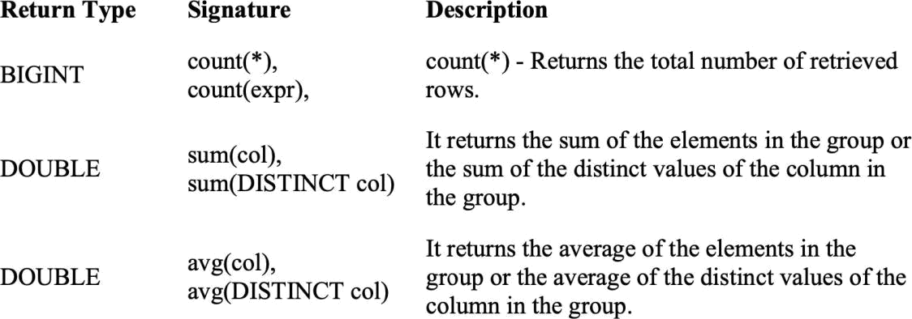

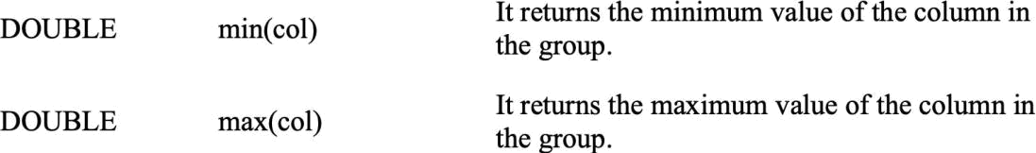

AI19741 Big Data Technology | 16 | 211501087

Creating an Index

An Index is nothing but a pointer on a particular column of a table. Creating an index means creating a pointer on a particular column of a table. Its syntax is as follows:

CREATE INDEX index_name
ON TABLE base_table_name (col_name, ...)
AS 'index.handler.class.name'
[WITH DEFERRED REBUILD]
[IDXPROPERTIES (property_name=property_value, ...)]
[IN TABLE index_table_name]
[PARTITIONED BY (col_name, ...)]
[
[ ROW FORMAT ...] STORED AS ...
| STORED BY ...
]
[LOCATION hdfs_path]
[TBLPROPERTIES (…)]

Example

Let us take an example for index. Use the same employee table that we have used earlier with the fields Id, Name, Salary, Designation, and Dept. Create an index named index_salary on the salary column of the employee table.
The following query creates an index:

hive> CREATE INDEX inedx_salary ON TABLE employee(salary) AS 'org.apache.hadoop.hive.ql.index.compact.CompactIndexHandler';

It is a pointer to the salary column. If the column is modified, the changes are stored using
an index value.

Dropping an Index

The following syntax is used to drop an index:

DROP INDEX <index_name> ON <table_name>
The following query drops an index named index_salary:
hive> DROP INDEX index_salary ON employee;

RESULT :

The program for the given problem statement is executed and output is verified successfully.

AI19741 Big Data Technology | 17 | 211501087



18/10/2024

AIM:
To export data from Hadoop using Sqoop to import data to Hive.
To export data into MySQL from HDFS, perform the following steps:

Step 1: Create a database and table in the hive.

create table hive_table_export(name string,company string, phone int, age int) rowformat delimited fields terminated by ‘,’;

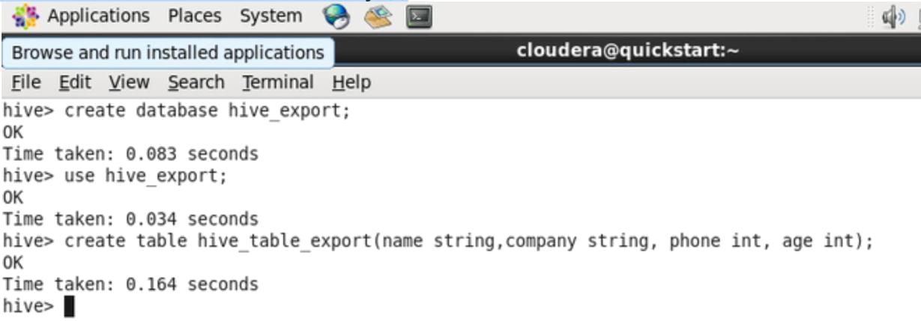

Step 2: Insert data into the hive table.

insert into hive_table_export values(“Ritik”,"Amazon",234567891,35);

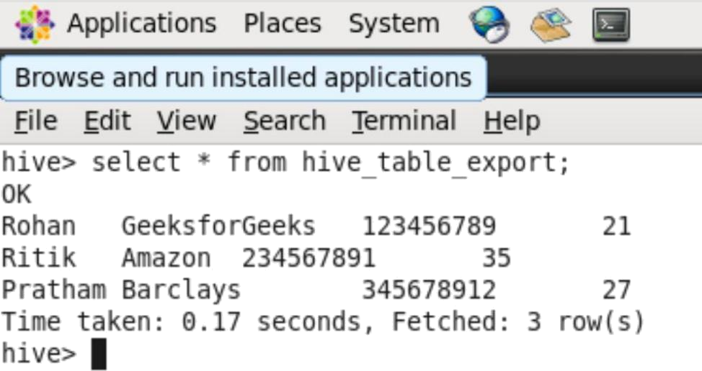

AI19741 Big Data Technology | 18 | 211501087

Step 3: Create a database and table in MySQL in which data should be exported.

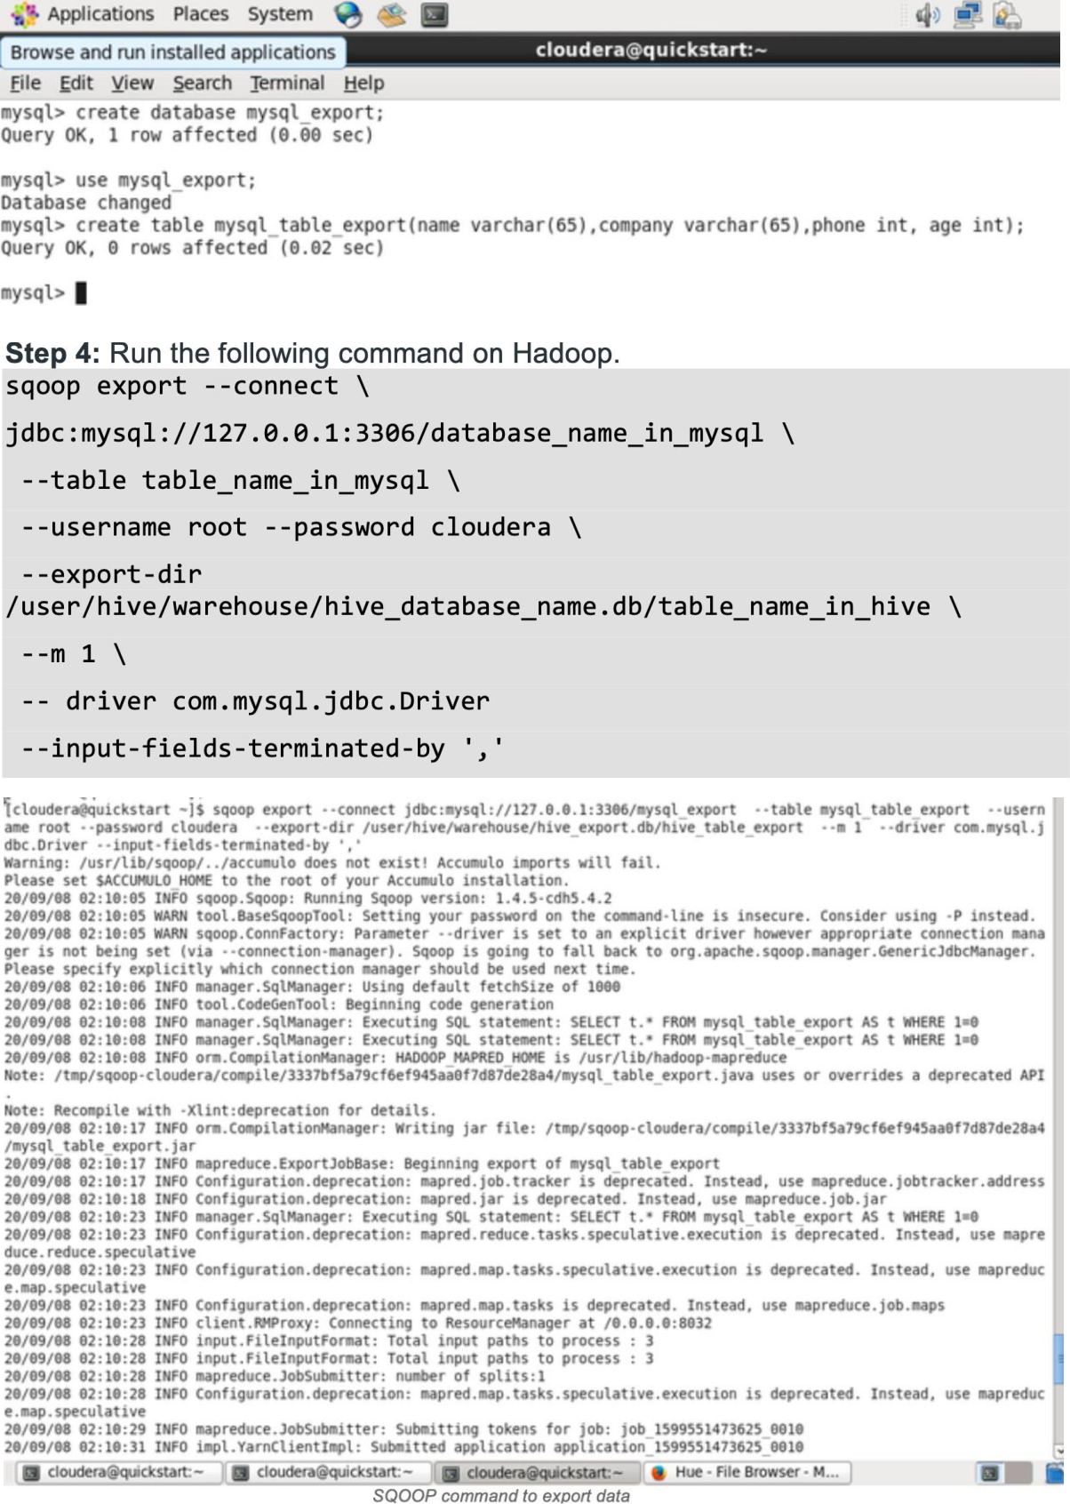

AI19741 Big Data Technology | 19 | 211501087



RESULT :

The program for the given problem statement is executed and output is verified successfully.

AI19741 Big Data Technology | 20 | 211501087

